**Azure Storage**



**Azure Storage** is a free, standalone tool from Microsoft that lets you easily manage and interact with your Azure Storage resources like Blob, File, Queue, and Table storage. It provides a graphical interface to upload, download, and organize data across multiple storage accounts.

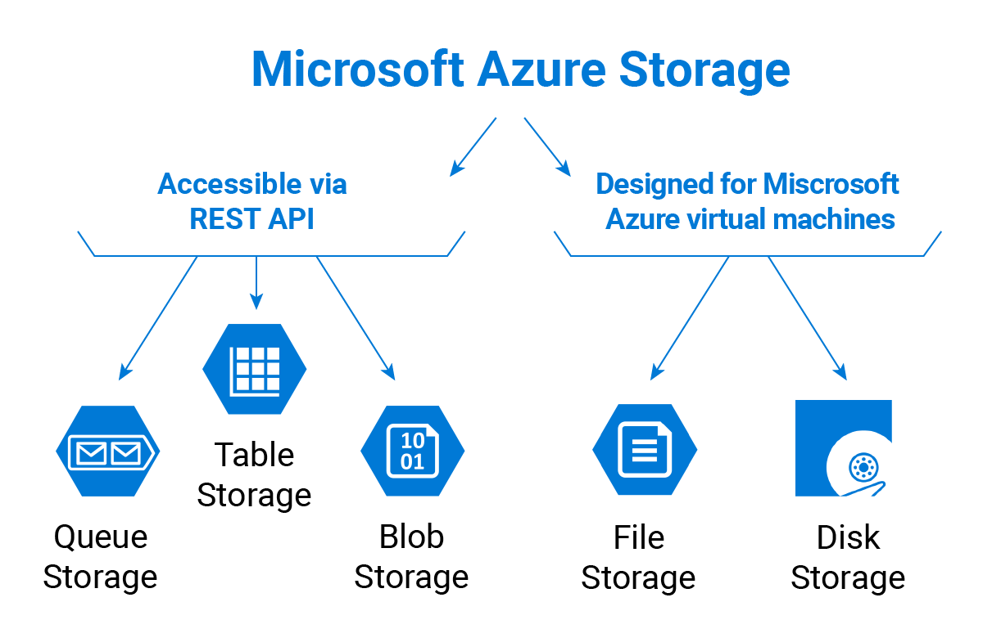

**Features :**

1. **User-Friendly Interface** – Provides a graphical UI to manage Azure Storage resources without using code or the portal.
2. **Multi-Account Support** – Connect and manage multiple Azure subscriptions and storage accounts in one place.
3. **Data Operations** – Easily upload, download, delete, and organize blobs, files, queues, and tables.
4. **Access Control** – Supports connecting via Azure AD, connection strings, or shared access signatures (SAS) for secure access.
5. **Cross-Platform Compatibility** – Available for Windows, macOS, and Linux, making it versatile for different environments.